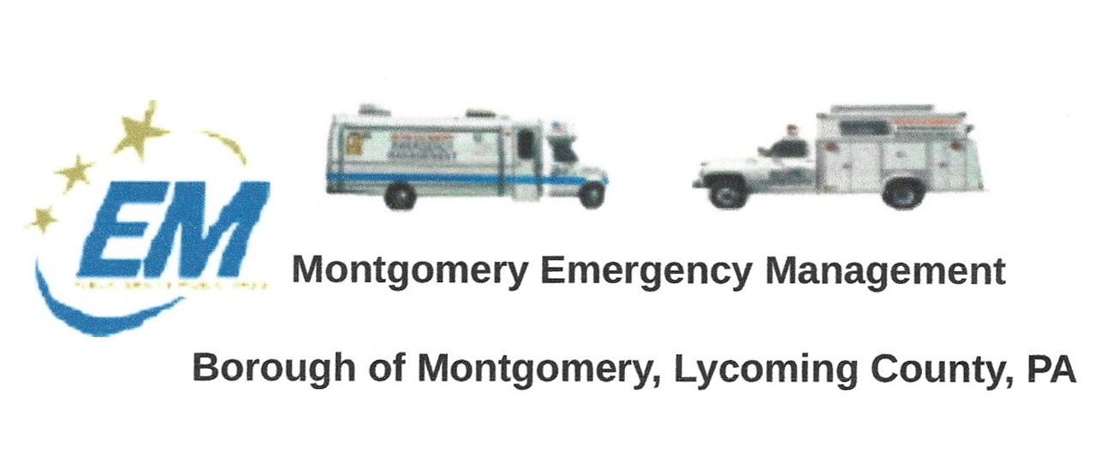

**Greg Gruver, EMA Coordinator. 77 East Houston Avenue, Montgomery, PA 17752**

Telephone: 570-547-1212 Cell: 570-419-4866 Email: [montema631@gmail.com](mailto:montema631@gmail.com)

**Fae Herb, Administrative Assistant. 102 Broad Street, Montgomery, PA 17752**

Cell: 570-506-9892 Email: [faeherb@aol.com](mailto:faeherb@aol.com)

Meeting Room and Equipment Building: 40 Thomas Avenue

Borough EOC: 570-547-1671 Fire Hall EOC: 570-547-1380

**INTERNET WEBSITE: www.montgomeryboroughema.org**

**The next regular meeting of the Montgomery Borough Emergency Management Agency will be:**

**THURSDAY, SEPTEMBER 9, 2021 AT 7 P.M.**

The best well plans do not always go as planned. Earlier in the year, the Montgomery Volunteer Fire Company were unable to book an Amusement vendor for their carnival….being persistent they secured a vendor, and the carnival was scheduled for Aug. 25-28. The residents cheered. Bands were scheduled, food ordered. On the morning of Wednesday, Aug. 25 as Dale and I were returning from our camping trip we passed the carnival grounds, we noticed no rides were set up. I contacted Steve Cook to see what had happened and was told that there had been no contact with the amusement vendor for a week and had no idea what was going on. Imagine contracting a clown for a child’s birthday party and the clown doesn’t show…..disappointment. **BUT**, the show must go on…..the Community rallied behind the Fire Company. Laporte Volunteer Fire Company donated 3 large inflatables, Warrior Run Area Fire Department and William Cameron Engine Company set up a firefighter challenger course for the young kids. Area vendors set up stands to sell their homemade wares and goodies. Lion’s Club sold ice cream, which was a welcome relief from the heat. The week ended with a parade Saturday afternoon and fireworks that night. You make the best you can out of a bad situation….and the Fire Company (and the community) sure did.

It will soon be 20 years since 4 planes that were hijacked by terrorists on 9/11/01 filled with innocent people hit the Twin Towers in NYC, the Pentagon in Virginia and passengers tried to take back their plane and crashed in a field in Pennsylvania. The 9/11 Memorial Motorcycle Ride will also be marking 20 years as they ride 42 miles throughout Lycoming County starting at Clinton Volunteer Fire Company, through S. Williamsport, Williamsport, Loyalsock, Montoursville, Hughesville, Muncy, Montgomery and back to the Clinton Twp. I have had the honor of being a passenger on Dale’s bike and I tear up as I see the people (young and old) line the streets, we ride under a flag, the bell choir ringing their bells, the most touching scene is the Naval Officer who stands at attention and salutes (on Rt. 220) as the first bike passes till the last bike goes by.. This year will be more meaningful after the 12 servicemen/women were recently killed by a suicide bomber in Kabul, Afghanistan. The EMA will have their communication truck set up at the Clinton Twp. Fire Company. Gates open at 10 a.m. with a memorial service at 2 p.m. Ride will begin to roll at 3 p.m.

EMA members will also be manning communications at the Balloonfest Airshow in Hughesville on Sept. 11-12th. Also honoring veterans and first-responders.

**SEPTEMBER REFRESHMENTS WILL BE SUPPLIED BY WAYNE SIMON**

**MEMBERS ARE REMINDED OF TUESDAY WEEKLY RADIO CHECK AT 6 P.M.**

Submitted by: Fae Herb-Administrative Assistant